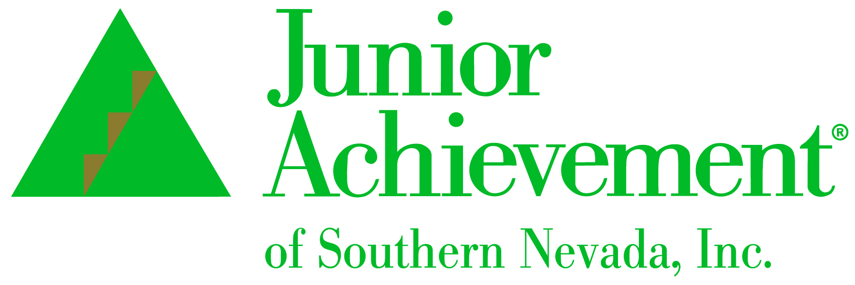
NEWS RELEASE
For Immediate Release

For More Information, Contact:
Michelle Jackson, President
Junior Achievement of Southern Nevada, Inc.
702-214-0503
michelle.jackson@ja.org

Junior Achievement of Southern Nevada
Announces New Board Member Sarah Lester from
U.S. Bank



LAS VEGAS, NV – Junior Achievement of Southern Nevada is proud to announce Sarah Lester has joined its board of directors. She is the senior vice president business banking market leader at U.S. Bank, where she is responsible for a team of 50 business bankers serving Las Vegas communities. In addition to her banking and financial acumen, she brings healthcare and Junior Achievement volunteering experience for a comprehensive financial health contribution to the nonprofit organization that teaches financial education to K-12 youth.

“We are excited to have Sarah as part of our board leadership team. Her passion for Junior Achievement’s mission is tried and true as shown through her personal volunteer time, and her experience and efforts in helping the community will be a great asset to our board," said Michelle Jackson, president and CEO of Junior Achievement of Southern Nevada.

Lester has volunteered with Junior Achievement for the past 15 years and has launched a pilot financial literacy advocacy position in all U.S. Bank's metropolitan areas. She has worked in the banking industry for 17 years and also graduated from the Consumer Bankers Association Executive Banking School.

Born in Dayton, Ohio, Lester attended Kaplan University in Cincinnati, Ohio, where she earned an associate degree in practical nursing. She worked in the health care field for five years.

“Coming from a nursing background, I believe wholeheartedly that there is a parallel between our physical health and financial health. I have seen this firsthand for several years and was instantly drawn to the work Junior Achievement does for our communities," said Lester. "Teaching our youth about the importance of financial literacy is something tangible we can do to help generations to come. I know this as a banker and also as a mother. I’ve seen too many times how a lack of financial literacy in our youth starts them off on the absolute wrong foot, significantly making their lives more difficult than they need to be. I know we can make a difference for so many with Junior Achievement."

About Junior Achievement of Southern Nevada
Junior Achievement of Southern Nevada, Inc. was founded locally in 1996. The organization is dedicated to providing financial education to students K-12, with a curriculum that spans from budget management to economic principals, workforce skills and credit. Junior Achievement of Southern Nevada reaches more than 20,000 students annually in the Las Vegas area with the help of 285 businesses and 6,800 business role models. For more information visit https://jasnv.org/ and follow on Instagram and Facebook.

About Junior Achievement USA® (JA)
Junior Achievement is the world's largest organization dedicated to giving young people the knowledge and skills they need to own their economic success, plan for their future, and make smart academic and economic choices. JA programs are delivered by corporate and community volunteers, and provide relevant, hands-on experiences that give students from kindergarten through high school knowledge and skills in financial literacy, work readiness and entrepreneurship. Today, JA reaches 4.5 million students per year in 115 markets across the United States, with an additional 5.8 million students served by operations in 120 other countries worldwide. Visit www.ja.org for more information.
# # #

